The Good Samaritan

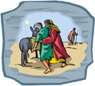

J | L | J | W | L
I | E | I | B | I
L | N | S | O | F
E | T | N | U | E
T | S | E | T | S

INN | JESUS | LIFE
OIL | TEST | WINE

