The Prophets of Judah
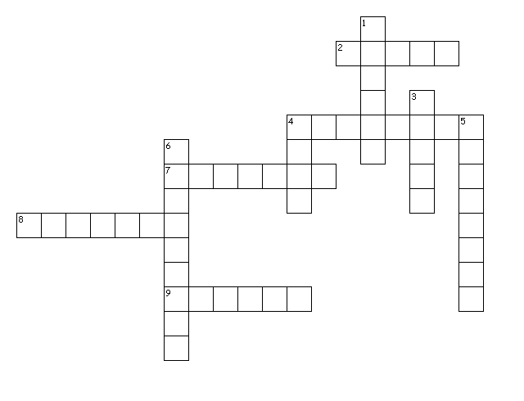

Across
2. Comfort, Assyria destroyed
4. Gloom and doom because of sin
7. Jerusalem punished by Babylon
8. Edom's doom
9. God's salvation through the Messiah

Down
1. Visions and faith
3. God wants right living and love
4. Locust plague and punishment
5. Questions unpunished evil
6. Judah's judgment and blessing

