The Prodigal Son
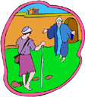

F | S | K | S | G
D | E | I | O | I
K | A | A | N | P
W | Z | D | S | C
E | B | O | R | T

DAD | FEAST | PIG
ROBE | SIN | SONS

