People of the Bible
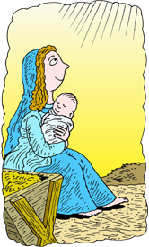

A | N | Y | A | J
I | O | R | B | E
D | A | A | E | S
Y | H | M | L | U
L | U | A | P | S

ABEL | JESUS | LYDIA
MARY | NOAH | PAUL

