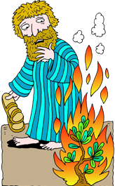
People of the Bible

L | K | M | L | D | D | R | J | D | W
K | E | U | A | A | A | O | U | D | Q
J | A | U | V | R | S | N | G | T | O
P | A | I | M | H | Y | H | I | V | H
H | D | C | U | A | A | E | J | E | M
H | P | A | O | N | S | L | E | B | L
A | H | E | O | B | G | I | S | N | Y
O | N | J | S | O | N | J | U | E | H
N | Y | G | D | O | G | A | S | L | P
S | E | S | O | M | J | H | M | K | V

DANIEL | DAVID | ELIJAH
GOD | JACOB | JESUS
JONAH | JOSEPH | JOSHUA
MARY | MOSES | NOAH
PAUL | RUTH | SAMUEL

