The Last Supper
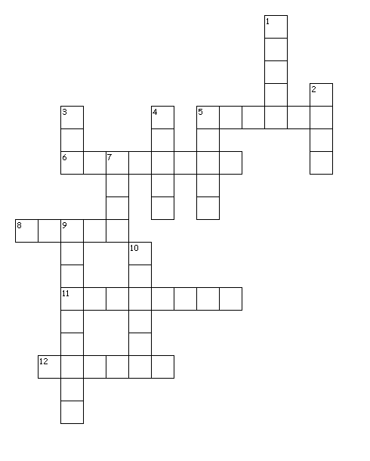

Across
5. Jesus said Judas would ____ Him
6. The name of this particular feast
8. ____ was the one who betrayed Jesus
11. What Jesus' blood symbolizes
12. What Mount did they go to later?
Down
1. The room that they all met in for the feast
2. The type of song they sang after the meal was finished
3. What did the disciples drink out of at the feast
4. What the cup represented
5. This represented Jesus' broken body
7. Jesus shed his blood for our ____
9. The name often referred to the twelve men
10. Number of disciples who ate at the last supper

