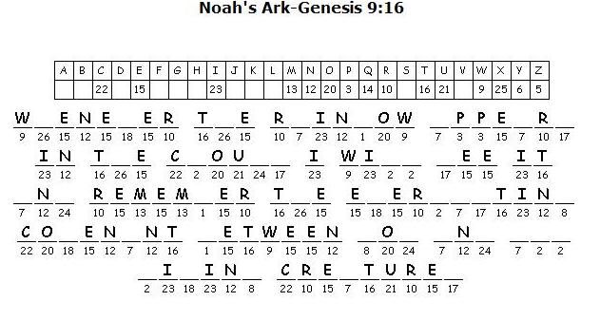
Fill in the missing letters to find out what the Bible verse.

