Fruit of the Spirit

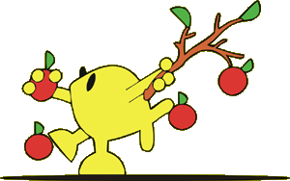

G | G | V | J | F
E | E | O | L | D
V | Y | E | O | Z
O | S | G | K | D
L | K | I | N | D

GOD | GOOD | JOY
KIND | LOVE | SELF

