Fruit of the Spirit

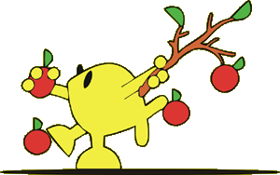
C | O | N | T | R | O | L | L | E | K
S | X | P | J | E | S | U | S | V | I
E | C | N | A | L | A | B | K | O | N
D | F | A | I | T | H | F | U | L | D
G | A | L | A | T | I | A | N | S | N
T | R | A | E | H | S | E | L | F | E
E | C | A | E | P | Y | J | N | S | S
S | S | E | N | D | O | O | G | C | S
E | D | U | T | I | T | T | A | E | E
Y | O | J | Z | G | E | N | T | L | E

ATTITUDE | BALANCE | CONTROL
FAITHFUL | GALATIANS | GENTLE
GOODNESS | HEART | JESUS
JOY | KINDNESS | LOVE
PATIENCE | PEACE | SELF

