The Commandments

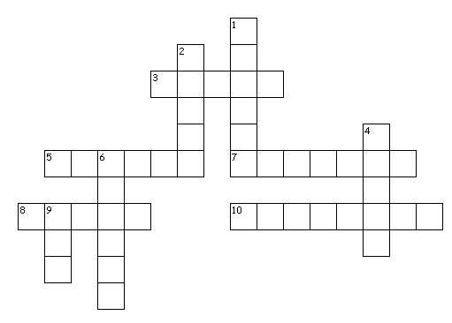

Across
3. ____ your father and your mother
5. You shall not ____ adultery
7. Remember the ____ day by keeping it holy
8. You shall not give ____ testimony against your neighbor
10. You shall not make for ____ an idol in the form of anything

Down
1. 20:1 The Ten Commandments
2. You shall not ____ your neighbor's house
4. You shall have no ____ gods before me
6. You shall not ____ the name of the Lord your God
9. And God spoke ____these words

