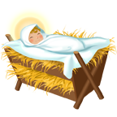
The Birth of Jesus


Across
3. An ____ appeared in front of Joseph to tell about the birth of a Savior
4. Mary had a husband named ____
6. The King who was jealous of the birth of Jesus
7. This is the city that Joseph and Mary first took Jesus to

Down
1. The ____ brought various gifts for Jesus
2. Jesus was born in this town
4. The son of Marry was named
5. A _____ led the way to Jesus

