Birds of the Bible
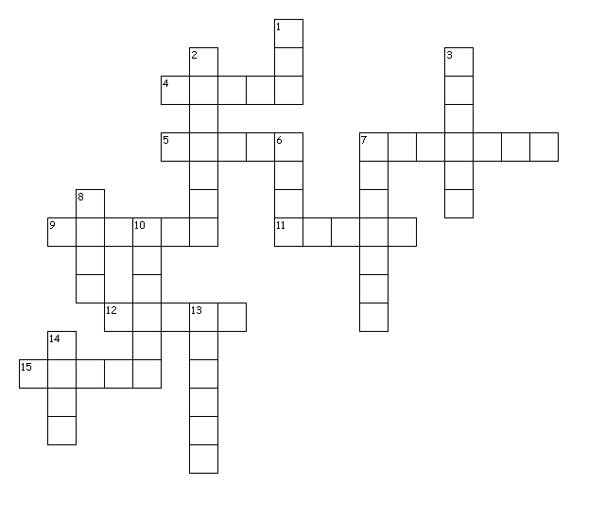
Across
4. Exodus 16:13
5. Jeremiah 8:7
7. Psalm 84:3
9. Leviticus 11:19
11. Proverbs 23:5
12. Leviticus 11:19
15. Genesis 8:7
Down
1. Psalm 102:6
2. Leviticus 11:13
3. Isaiah 38:14
6. Leviticus 11:14
7. Psalm 84:3
8. Genesis 8:8
10. Leviticus 12:6
13. Leviticus 11:18
14. Job 39:26

