Armor of God
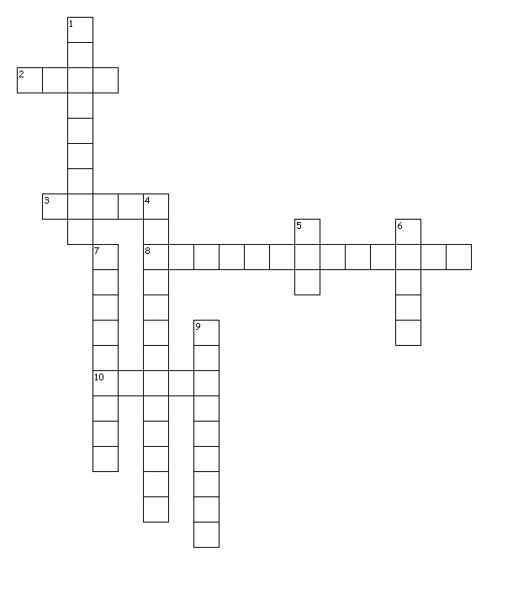
Across
2. Stand _______
3. Be strong in the lord and his mighty
8. Feet ready for the ______
10. Belt of ______
Down
1. Sword of the spirit which is the _______
4. Breastplate of ______
5. Put on the full armor of ______
6. Take up the shield of _______
7. Take the helmet of ______
9. 6:10

